L/O G1. Join in discussion about stories. Names characters & places in stories. Talks about events and language. G2. Talks about important part of a story, retelling main event. G3. Discuss an incident and its effects in a story.
The Treasure of
Shark’s Tooth Island
Who? | When?
Ben Carver – 9 years old.  Jago Sparke – Captain of Firebird.  Mad Mason – Captain of un-named ship.  Abel Monkshood – first mate of Firebird. | A dark night but the moon sprang out from behind the clouds and the beach suddenly turned silver, grey and white.
Where? | What?
On a long thin Island made of rock, battered by churning seas with a clump of weather-beaten trees clinging to its centre. | A young boy is looking for his father’s buried treasure and is pursued by Pirate’s. They all meet on the Island and fight over the treasure.
Conclusion?
The two Captains knew the boy’s father – who was also a pirate. The treasure was not made up of gold or gems – it was the love of a father for his son. The boy decided to sail away and become a pirate.

L/O G1. Join in discussion about stories. Names characters & places in stories. Talks about events and language. G2. Talks about important part of a story, retelling main event. G3. Discuss an incident and its effects in a story.
The Treasure of
Shark’s Tooth Island
Who? | When?
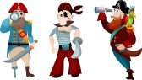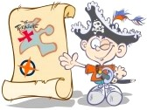
Where? | What?
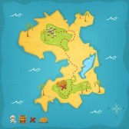 | 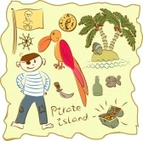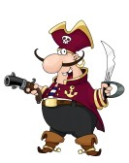
Conclusion?
